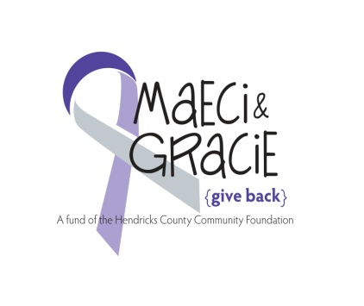

**Maeci & Gracie's**

**"GIVE BACK"**

**Girls Fast Pitch Softball Tournament**

**September 22nd, 23rd & 24th**

**Danville Twin Bridges Girls Softball Park**

Mail this form and a check for $300 made payable to HCCF (MEMO: Maeci & Gracie”) for $300 to:

Stephanie Bennett – 317.727.5489

1717 Chatham Place

Danville, IN 46122

**Team Name:**­­­­­­­­­­­­­­­­­­­________________________________________________

**Team Captain:**_______________________________________________

**Contact phone number:**________________________________________

**Contact e-mail:**_______________________________________________

***DEADLINE IS SEPTEMBER 10TH***

**Tournament will be held at the [Danville Twin Bridges Girls Softball Park   
1490 E. CR 200 S. Danville, Indiana](http://www.active.com/softball-tournament/danville-in/maeci-and-gracie-give-back-a-wish-2012" \l "Map) starting at Friday, September 22nd, Saturday, September 23rd & Sunday September 24th.**

Please check the box that applies to your age of team:

 **10U**

 **12U**

 **14U**

 **16U**

Email – [maeciandgraciegiveback@gmail.com](mailto:maeciandgraciegiveback@gmail.com) with questions.

**A FUND OF THE HENDRICKS COUNTY COMMUNITY FOUNDATION**

**6319 East U.S. Hwy 36. Ste 211. Avon, IN 46123**